LAB Manual

PART A

(PART A : TO BE REFFERED BY STUDENTS)

**Experiment No.07**

**A.1 Aim:**

Write a program to apply 2 level decomposition using LPF and HPF filter Banks on given image.

**A.2 Prerequisite:**

1 Matlab programming syntax (Refer the Matlab manual).

2. Knowledge of fundamentals of wavelet and decomposition using filter banks and subsampling.

2. Availability of Soft copy of your Photograph for experiment.

**A.3 Outcome:**

**After successful completion of this experiment students will be able to**

1. Apply 2 level of decomposition using LPF and HPF filter banks and down sampling on given image.
2. Differentiate the availability of Low and high frequency areas at various location
3. Identify applications of transforms studied.

**A.4 Theory:**

**A.4.1. Introduction of Wavelet**

* Wavelet
  + A small wave
* Wavelet Transforms
  + Convert a signal into a series of wavelets
  + Provide a way for analyzing waveforms, bounded in both frequency and duration
  + Allow signals to be stored more efficiently than by Fourier transform
  + Be able to better approximate real-world signals
  + Well-suited for approximating data with sharp discontinuities
* Fourier Transform (FT)
  + One way to find the frequency content
  + Tells how much of each frequency exists in a signal
* **Limitation of Fourier Transform**

FT Only Gives what Frequency Components Exist in the Signal. The Time and Frequency Information can not be Seen at the Same Time. Time-frequency Representation of the Signal is Needed.

Short Time Fourier Transform (STFT) provides the time and frequency information

* **Drawback of STFT**
* Unchanged Window
* Dilemma of Resolution
  + Narrow window -> poor frequency resolution
  + Wide window -> poor time resolution
* Heisenberg Uncertainty Principle
  + Cannot know what frequency exists at what time intervals

The drawbacks of STFT is resolved using Wavelet where the dynamic window is used for signal analysis.

Multi resolution Analysis of images can be done using Wavelets, using the concept of arithmetic coding, level of decomposition of images using filter banks.

* **Multiresolution Analysis** 
  + Analyze the signal at different frequencies with different resolutions
  + Good time resolution and poor frequency resolution at high frequencies
  + Good frequency resolution and poor time resolution at low frequencies
  + More suitable for short duration of higher frequency; and longer duration of lower frequency components
* **An example of 2 level decomposition using filter bank.**

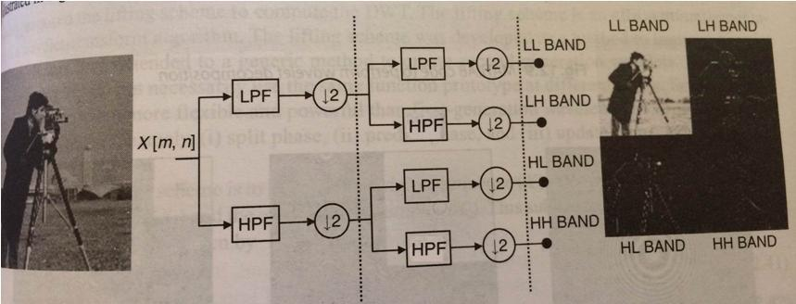

Figure 1: Use of Filter Banks for decomposition

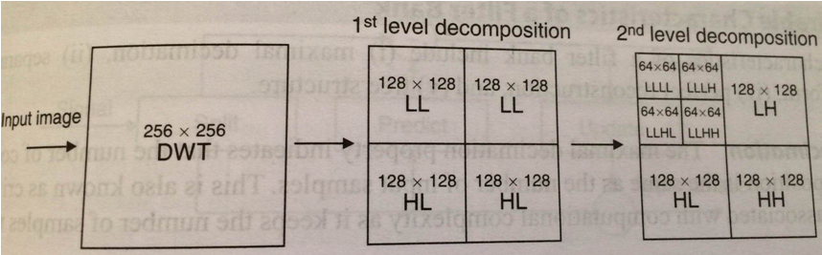

Figure 2: 2 level decomposition of an Input Image

**A.5 Procedure/Algorithm:**

**A.5.1:**

**TASK 1:**

1. Read the i/p image

2. Resize the image to convert it into square matrix.

3. Apply combination of Filter Banks and down sampling to decompose the image for 2 levels.

4. Display the decomposed images for particular level and display in same matrix

5. Observe the presence of High and low frequency areas in all bands.

6. Further decompose the image to the 2nd level

7. Observe the presence of High and low frequency areas in all bands.

8. Save and close the file and name it as **EX7_Task1_your Roll no.m**

**********************

PART B

|  |  |
| --- | --- |
| Roll No.: N049 | Name: Tarun Tanmay |
| Class: MBATech CE | Batch: B3 |
| Date of Experiment: 17/09/2020 | Date of Submission |
| Grade: | Time of Submission: |
| Date of Grading: |  |

**B.1 Software Code written by student:**

Code:

clear all;

clc;

a=imread('/Users/tjrox0825/Desktop/Research.jpeg');

ag=rgb2gray(a);

ar=imresize(ag,[256,256]);

ad=double(ar);

[row,col]=size(ad);

figure('name','Figures');

subplot(3,3,1);

imshow(ar);

title('Original image');

lpmask=([1 1 1; 1 1 1; 1 1 1]/9);

hpmask=([-1 -1 -1; -1 8 -1; -1 -1 -1]/9);

lp=[];

hp=[];

for i=1:row

for j=1:col

lpsum=0;

hpsum=0;

if i==1 || i==row || j==1 || j==col

lp(i,j)=ad(i,j);

hp(i,j)=ad(i,j);

else

for k=1:3

for l=1:3

lpsum=lpsum+(ad(i+k-2,j+l-2)*lpmask(k,l));

hpsum=hpsum+(ad(i+k-2,j+l-2)*hpmask(k,l));

end

end

lp(i,j)=lpsum;

hp(i,j)=hpsum;

end

end

end

lpi=uint8(lp);

subplot(3,3,2);

imshow(lpi);

title('LPF Level 1');

hpi=uint8(hp);

subplot(3,3,3);

imshow(hpi);

title('HPF Level 1');

lpf=[];

hpf=[];

k=1;

for i=1:2:row

l=1;

for j=1:2:col

lpf(k,l)=lp(i,j);

hpf(k,l)=hp(i,j);

l=l+1;

end

k=k+1;

end

dlp=uint8(lpf);

subplot(3,3,4);

imshow(dlp);

title('Downsized LPF');

dhp=uint8(hpf);

subplot(3,3,5);

imshow(dhp);

title('Downsized HPF');

[r,c]=size(lpf);

ll=[];

lh=[];

hl=[];

hh=[];

for i=1:r

for j=1:c

llsum=0;

lhsum=0;

hlsum=0;

hhsum=0;

if i==1 || i==r || j==1 || j==c

ll(i,j)=lpf(i,j);

lh(i,j)=lpf(i,j);

hl(i,j)=hpf(i,j);

hh(i,j)=hpf(i,j);

else

for k=1:3

for l=1:3

llsum=llsum+(lpf(i+k-2,j+l-2)*lpmask(k,l));

hlsum=hlsum+(hpf(i+k-2,j+l-2)*lpmask(k,l));

lhsum=lhsum+(lpf(i+k-2,j+l-2)*hpmask(k,l));

hhsum=hhsum+(hpf(i+k-2,j+l-2)*hpmask(k,l));

end

end

ll(i,j)=llsum;

lh(i,j)=lhsum;

hl(i,j)=hlsum;

hh(i,j)=hhsum;

end

end

end

lli=uint8(ll);

subplot(3,3,6);

imshow(lli);

title('LL Band');

lhi=uint8(lh);

subplot(3,3,7);

imshow(lhi);

title('LH Band');

hli=uint8(hl);

subplot(3,3,8);

imshow(hli);

title('HL Band');

hhi=uint8(hh);

subplot(3,3,9);

imshow(hhi);

title('HH Band');

**B.2 Input and Output:**

**Input Images:**

**Output Images:**

1. **For each level of decomposition as per the procedure discussed in section A.5.**

**B.3 Observations and learning:**

LPF and HPF filter banks help us separate information in an image and are the basic principle behind wavelets. Wavelets are small waves, which are used to form large waves. Filter banks also help in decomposition. For first level decomposition, LPF and HPF were applied to the original image and then they were downsized to half their size. For second level decomposition, LPF and HPF were applied to both the downsized images. For LPF, the contents of the image get blurred but are not lost while for HPF, the thin edges are observed.

**B.4 Conclusion:**

I have learnt the concept of 2 level decomposition using LPF and HPF filters. I have also implemented it in MATLAB.

**B.5 Question of Curiosity**

**What is multiresolution analysis? How it can be achieved using Image pyramid and filter banks?**

Answer: Multiresolution analysis is the design method of most of the practically relevant discrete wavelet transforms (DWT) and the justification for the algorithm of the fast wavelet transform (FWT). An Image Pyramid is a collection of decreasing resolution images arranged in the shape of a pyramid. The Base is a high-resolution representation of an image of size N x N being processed whereas the apex contains low-resolution approximation. As one moves up the pyramid, both size and resolution decrease. Pyramid methods may be applied to analysis in several ways. It uses three parameters: pattern matching, the estimation of integrated properties within local image regions and Pattern Scale. Pattern matching is used to locate a particular target pattern that may occur at any scale within an image. The pattern is convolved with each level of the image pyramid. All levels of the pyramid combined contain just one third more nodes that there are pixels in the original image. Thus, the cost of searching for a pattern at many scales is just one third more than that of searching the original image alone.

************************